BHER Strategic Plan 2021-2022

Who we are
The Business+Higher Education Roundtable (BHER) is a non-partisan, not-for-profit organization bringing together Canada’s largest companies and leading post-secondary institutions. Since 2015, BHER has worked to harness the strengths of Canada’s business and post-secondary education sectors to build opportunities for young Canadians, boost innovation and drive collaboration.

Our vision
Canada’s business and post-secondary leaders face many challenges. Working together to solve these challenges is more critical than ever and will strengthen Canada’s economy along the way. BHER is a connector and a convenor.

We bring people together to create:
A thriving Canada where everyone has an opportunity to reach their potential.

Our mission
Creating opportunity through collaboration.

Our values
WE TAKE ACTION.
- We act on evidence. Information and data are the basis for what we do.
- We act with confidence. We are bold in our opinions and output.
- We drive transformation. We don’t do things the old way. We stay ahead of the curve.
- We act in partnership. Relationship builders are who we are.
- We connect people, collaborate with groups, and develop partnerships between everyone in our ecosystem.
- We act for all. The outcome of our work is for the benefit of everyone in Canada.

Our Strategic Priorities
There are three major challenges in the country that drive BHER’s priorities each year:

- Skills and Talent:

We will expand our program delivery to increase Canada’s work-integrated learning capacity and bring together stakeholders to help Canada’s people, industries and institutions navigate the future of work.

- Innovation:

We will boost Canada’s research, development, and innovation culture that will drive economic development by facilitating collaboration between post-secondary institutions and businesses on shared challenges and opportunities.

- Connecting, convening, and communicating:

We will be the leading voice and national hub for cultivating conversation and driving action on skills, talent, and innovation with leaders from diverse sectors across the country. This is the central tenet of how we work.

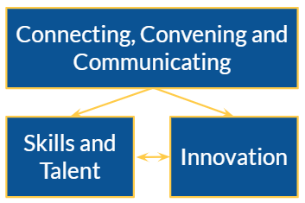

In addition to focusing on these three priorities, in 2021-2022 we will continue to build our organizational capacity.

Executive Summary

BHER has three strategic priorities and a continued focus on building our organizational capacity. Below is a 1-page summary of this year’s priorities, goals, and expected outcomes. Additional detail can be found on the subsequent pages.

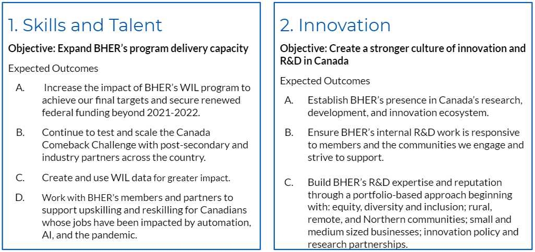

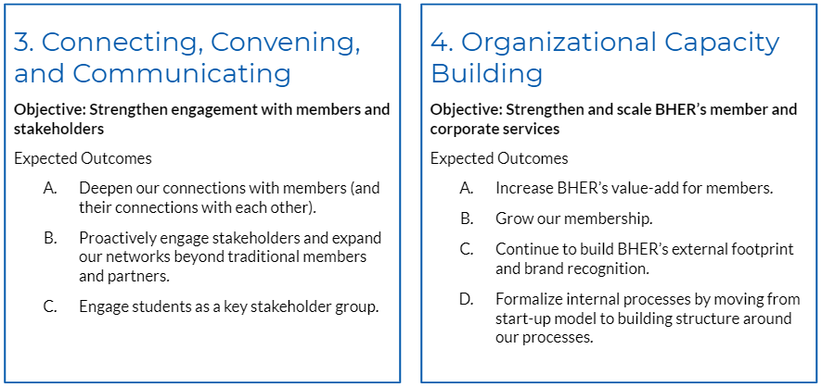

2021-2022 Goals and Expected Outcomes
For each of our strategic priorities, we have outlined the main objectives we will work towards over the next year.

1. Skills and Talent
Objective: Expand BHER’s program delivery capacity
Expected Outcomes
- Increase the impact of BHER’s WIL program to achieve our final targets and secure renewed federal funding beyond 2021-2022.
  - Launch remaining WIL partnerships and the WIL resource hub.
  - Broaden partnership capacity by developing priority areas through subject-matter expertise.
  - Develop compelling narratives about the experiences, impacts, and outcomes of BHER’s partnerships and products.
  - Leverage BHER’s extensive program experience, member and partnership network, research, tools, and resources to secure a re-investment of federal funding in BHER focussed strategically on closing the remaining gaps in the WIL ecosystem.

- Continue to test and scale the Canada Comeback Challenge with post-secondary and industry partners across the country.
  - Run a focused summer Challenge for students as well as fall/winter versions of the program in conjunction with the academic calendar.
  - Make program adjustments based on lessons learned from the first year of running the program.
  - Engage more fully with campus champions and employer partners for program promotion, expansion, and delivery.
  - Leverage the Canada Comeback Challenge to provide a plug-and-play program option for new and existing WIL partners.

- Create and use WIL data for greater impact.
  - Lead the development and coordination of a national strategy for WIL data collection and evaluation.
  - Create robust WIL data, both quantitative and qualitative, with delivery partners and national WIL stakeholders, to better understand outcomes, inform decision making, and new program opportunities.
  - Communicate the impacts and lead by example on knowledge translation and mobilization.

- Work with BHER’s members and partners to support upskilling and reskilling for Canadians whose jobs have been impacted by automation, AI, and the pandemic.
  - Establish credibility in the space by building on existing research and expertise, including from our members and partners, to complete an environmental scan and needs assessment.
  - Connect and convene leaders in the space, including businesses, post-secondary institutions, students, and other stakeholders to address the needs we have identified.

2. Innovation
Objective: Create a stronger culture of innovation and R&D in Canada
Expected Outcomes
- Establish BHER’s presence in Canada’s research, development, and innovation ecosystem.
  - Connect and convene employers and educators to identify industrial strategy, R&D, and innovation challenges and opportunities.
  - Curate existing content and produce research outputs that generate new ideas and identify potential solutions and interventions.
  - Bring together leaders from multiple sectors, including government, industry and post-secondary, to work together on these issues.

- Ensure BHER’s internal R&D work is responsive to members and the communities we engage and strive to support.
  - Work with members and other stakeholders to carry out and disseminate rigorous, high-quality research and analysis that address critical issues facing businesses and higher education.
  - Build new committees and advisory structures to engage more often and more directly with members and leverage their insight and expertise.
  - Broker relationships and build connections between academic and non-academic communities to transfer knowledge, inform decisions, and turn research into action.
  - Use inclusive research methods that involve people, their communities, and their lived experiences.

- Take a portfolio-based approach to R&D.
  - Build BHER’s R&D expertise and reputation in areas that support: equity, diversity and inclusion; rural, remote, and Northern communities; small and medium sized businesses; innovation policy and research partnerships, Francophone Canada; and high impact teaching and learning practices.
  - Integrate BHER’s R&D, WIL partnerships, and tools and resource development work to build stronger teams and add value to members and partners.
  - Create pathways and leverage our expertise to scale successful WIL and non-WIL projects and/or pilots into national programs with broad impact.

3. Connecting, Convening, and Communicating
Objective: Strengthen engagement with members and stakeholders
- Deepen our connections with members (and their connections with each other).
  - Continue to engage leaders throughout and deeper into our member organizations (i.e. not just at the top).
  - Create new, mutually beneficial ways for our member organizations to work with us through research and program advisory committees and member-to-member relationship building.
  - Strengthen communication channels with members so we know more about what they’re doing and can help them build awareness and tell their stories.
- Proactively engage stakeholders and expand our networks beyond traditional members and partners.
  - Continue to establish BHER as a national organization with a regional presence by expanding our member and partnership approach beyond the big industries, big schools, and big cities.
  - Promote community-engaged research and partner-to-partner relationships that foster collaboration among groups that are not normally connected by geography, sector, or special interest.
  - Bring together regional skills, talent, and innovation leaders to mobilize BHER’s WIL resources and other R&D outputs.
- Engage students as a key stakeholder group.
  - Increase the connection and integration of BHER’s Student Advisory Board into our research, development, and program activities.
  - Keep students front of mind and engaged as stakeholders.

4. Organizational Capacity Building
Objective: Strengthen and scale BHER’s member and corporate services
- Increase BHER’s value-add for members.
  - Communicate the strategic value and benefits of a BHER membership.
  - Engage members more through research and program design, content and information sharing, and convening activities.
- Grow our membership.
  - Recruit new members that provide geographic and industry diversity.
  - Create new membership tiers to provide access for more small and medium sized organizations.
- Continue to build BHER’s external footprint and brand recognition.
  - Increase strategic communications and relationship building activities.
  - Become a leader in member and stakeholder engaged knowledge translation and knowledge mobilization.
  - Develop BHER’s government relations strategy for all three levels of government.

- Formalize internal processes by moving from start-up model to building structure around our processes.
  - Develop BHER’s internal capacity and structures around finances and HR, particularly performance management and training and development.

